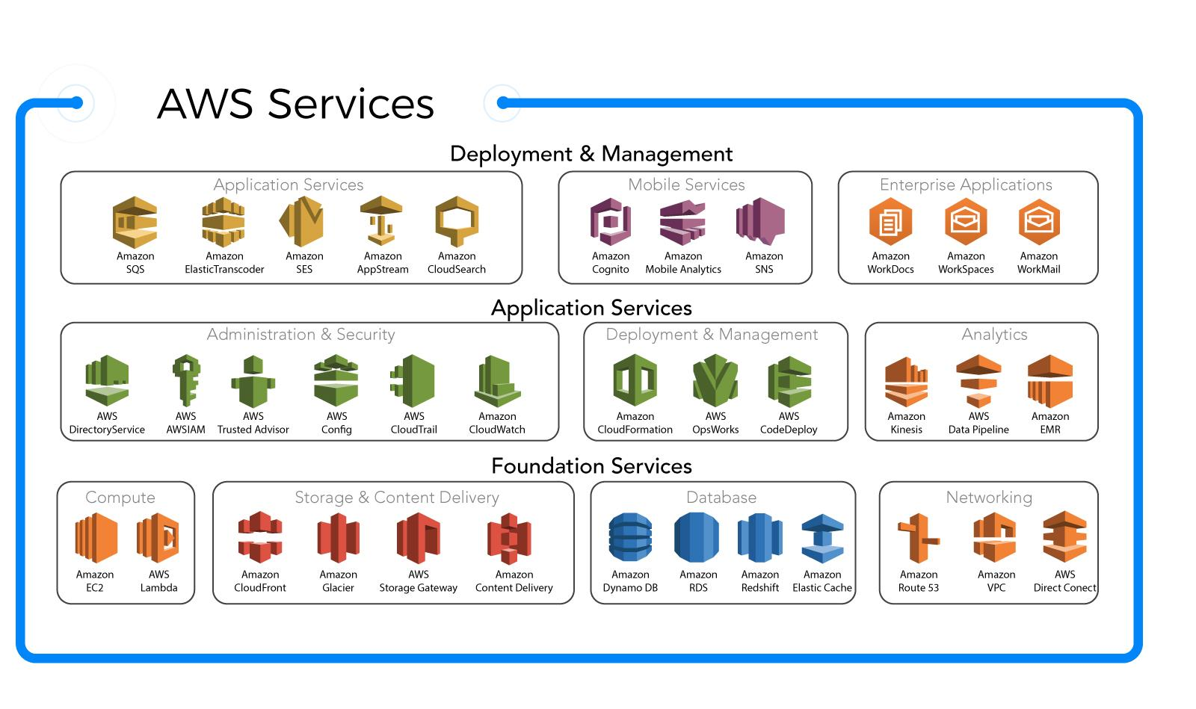

* Compute
* Storage
* Management and Security
* Data Base
* NetWork and Connectivity